University of Maryland, Baltimore County
Department of Information Systems
Anish Kandel
MGMT 489 - Independent Study
Dr. Karen Chen
December 10, 2025
Case Study 4: How Data Storytelling Influenced Medical Practice — The Semmelweis Handwashing Case

Source 1: DataCamp. (n.d.). How data storytelling could save lives: The case study of Ignaz Semmelweis. https://www.datacamp.com/blog/how-data-storytelling-could-save-lives-the-case-study-of-semmelweis

Source 2: Kaggle. (n.d.). Handwashing discovery dataset.
https://www.kaggle.com/datasets/argieg/discovery-of-handwashing-data

I. Source and Data Acknowledgement

This case study is based on the historical data and analysis presented in “How Data Storytelling Could Save Lives – The Case Study of Ignaz Semmelweis” published by DataCamp. The presented dataset, visualizations, and analytics are publicly available through DataCamp and Kaggle and have been widely used as an instructional example of how data can influence real-world decision-making.

For this case study, I did not recreate or simulate the dataset, nor did I redesign the original visualizations. Instead, I directly used the existing dataset and charts provided in the source materials and focuseed on interpreting the graphs, persuading a narrative, and extracting insights through a data storytelling perspective. A Jupyter Notebook containing the original analysis and visualizations is included as supporting material to demonstrate transparency.
Organizational Context

In the mid-19th century, hospitals across Europe faced dangerously high maternal mortality rates due to childbed fever. However, two maternity clinics at Vienna General Hospital had significantly differing death rates. The doctors at the time lacked the analytical skills and cultural awareness necessary to figure out the cause of such difference. Meanwhile, Hungarian doctor Ignaz Semmelweis started gathering and analyzing mortality data between the two clinics and eventually found that one of the main causes of infection was poor hygiene, notably doctors not washing their hands after performing autopsies.

This argument is particularly rationale not only because of the discovery but also because of its data storytelling perspective in bringing a signigficant change. Semmelweis found it difficult to persuade his colleagues, despite the fact that the data strongly demonstrated a significant drop in death rates following the introduction of handwashing. The numbers were there, but the narrative was not successfully presented in a manner consistent with the attitudes, motivations, and culture of the medical establishment at the time. This case, perhaps, is one of the first and most significant instances of how data may have a direct impact on people's lives when it is presented and communicated effectively . This also depicts the consequence of not turning facts into a convincing story that decision-makers would embrace.

Communication Goals
The goal of this case study is to show how data storytelling can fill the gap between evidence and action. Using the Semmelweis dataset and its associated visualizations, this case study examines how simple comparative charts, when combined with the right narrative, can challenge assumptions, depicts causal relationships, and drive behavioral change.
Rather than focusing on advanced analytics, this case emphasizes clarity, contrast, and timing in communication. The objective is to highlights the importance of evidence based narrative through an effective data storytelling in influencing policy, professional practice, and organizational culture.

Audience
This case study can be useful to Healthcare executives, public health experts, legislators, and organizational leaders who depend on statistics to make executive decision. It is also very useful for managers, students, and data analysts who want to know why compelling evidence isn't always sufficient and how narrative can influence whether data inspires resistance or action.

Key Story Elements

This case study follows a classic data storytelling structure:
- Context: High maternal mortality rates with no c;lear explanation.
- Conflict: Two clinics with significamtly different results and resistance from medical professionals.
- Evidence: Data showing mortality rates before and after the introduction of handwashing.
- Insight: Relationship between hygiene practices and survival.
- Outcome: Delayed adoption due to poor communication, lack of data driven narratives and cultural resistance.
- Lesson: Data must be conveyed as a strong narrative/storyto drive change.

Data and Visualization
The visualizations used in this case study were taken directly from the DataCamp and Kaggle materials associated with the Semmelweis dataset. These charts include comparisons of mortality rates across clinics and timelines showing changes before and after handwashing policies were introduced.
While the visuals themselves were not redesigned, the interpretation of these data here is original. The focus is on how visual contrast and trends made the findings clear, even with limited statistical tools. This reinstates the idea that effective data storytelling does not depend on complex data models, but on selecting the right visuals and framing them within a rationale narrative.

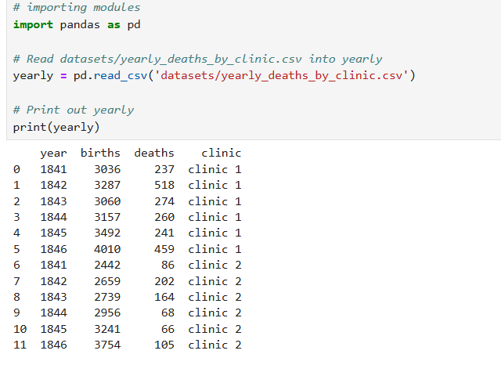
1. How did maternal death rates differ between the two maternity clinics within the same hospital?

Total Deaths by Clinic
The first visualization compares total maternal deaths between the two maternity clinics at the Vienna General Hospital. One clinic consistently shows a much higher number of deaths than the other. At face value, this chart immediately raises concern—two clinics operating under the same hospital, treating similar patients, yet producing dramatically different outcomes.
Interpretation:
This chart sets the stage for the entire story. It forces the viewer to ask why such a difference exists. The power of this visualization lies in its simplicity: no advanced statistics are needed to see that something is fundamentally wrong. From a data storytelling perspective, this chart establishes urgency and creates the initial tension in the narrative.

2. How severe was the mortality problem, and why can it be described as an “alarming” outlier?

This visualization highlights just how extreme the mortality rate was in one clinic compared to the other, often reaching levels that were unacceptable even by 19th-century standards. Seeing these numbers visually makes the crisis impossible to ignore.
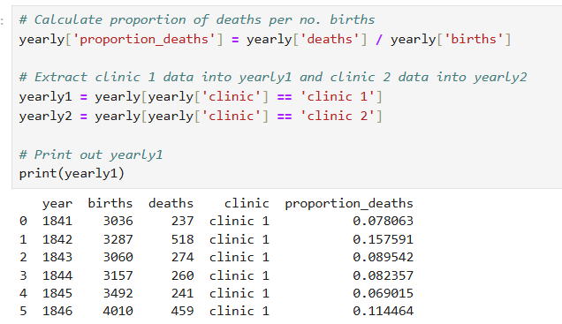

Interpretation:
Numbers on their own can feel abstract, but when framed as an “alarming” outlier, they gain emotional weight. This chart turns raw data into a moral question: How could this be allowed to continue? It shows how data can provoke discomfort, which is often necessary for change to begin.

3. What change occurred in maternal mortality after handwashing was introduced as a practice?

By showing deaths over time, this visualization reveals patterns rather than isolated incidents. The trend shifts noticeably after handwashing becomes standard practice.
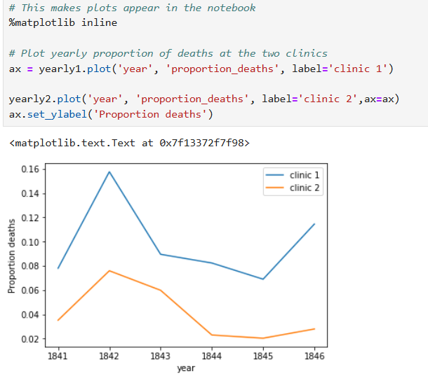

Interpretation:
This chart reinforces trust in the insight. It shows that the reduction in deaths was not a coincidence or a one-time fluctuation, but a sustained improvement. In modern organizations, this kind of time-series evidence is critical for convincing decision-makers that a solution is reliable and scalable.

4. How did maternal deaths trend over time before and after the intervention?
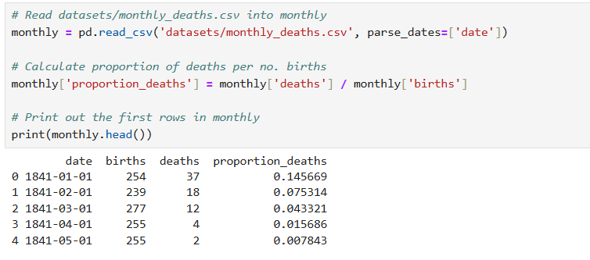
By showing deaths over time, this visualization reveals patterns rather than isolated incidents. The trend shifts noticeably after handwashing becomes standard practice.

Interpretation:
This chart reinforces trust in the insight. It shows that the reduction in deaths was not a coincidence or a one-time fluctuation, but a sustained improvement. In modern organizations, this kind of time-series evidence is critical for convincing decision-makers that a solution is reliable and scalable.

5. How did outcomes differ between clinics staffed by doctors versus midwives?

This visualization contrasts outcomes between clinics staffed by doctors and those staffed by midwives. The doctors’ clinic consistently had higher death rates before handwashing was introduced.
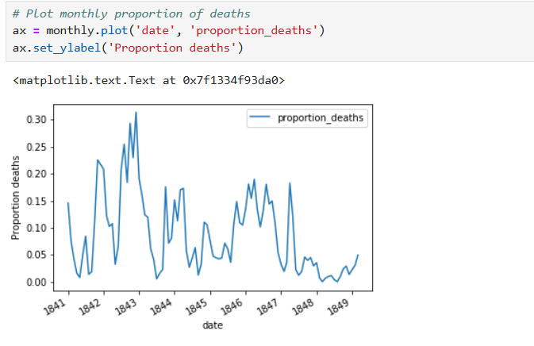

Interpretation:
This chart challenges assumptions and professional hierarchy. It shows how authority does not always align with effectiveness. From a data storytelling lens, this visualization is powerful because it confronts bias—something that often blocks acceptance of data-driven insights in organizations.

6. What external factors contributed to increased mortality risk in the doctors’ clinic?

This visualization connects spikes in mortality to external factors, such as increased exposure to cadavers during autopsies.

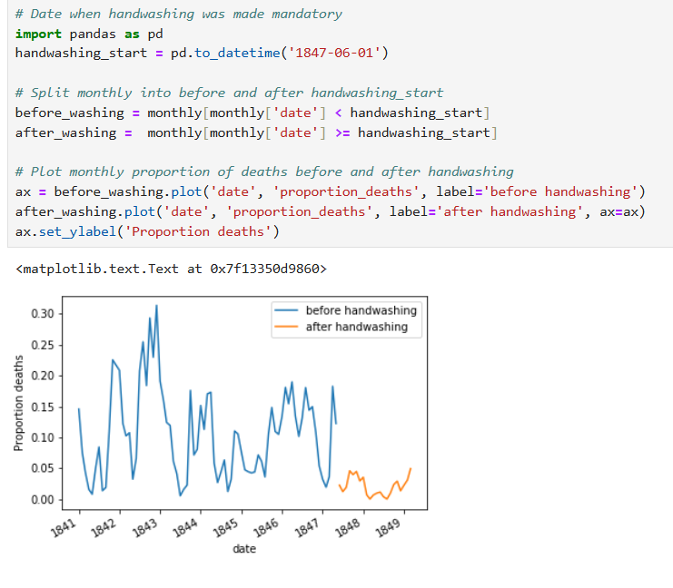

Interpretation:
Here, the data adds context rather than just comparison. It explains why the deaths were happening, not just that they were happening. This step is critical in storytelling: it transforms correlation into understanding and strengthens the argument for change.

7. How does combining mortality trends with the adoption of handwashing practices strengthen the overall evidence for causality?

The final visualization combines the decline in mortality with the adoption of handwashing practices, showing both trends together.
Interpretation:
This combined view delivers the final message of the story: evidence works when it is connected, not fragmented. Seeing behavior change alongside improved outcomes makes the lesson unmistakable. From a storytelling perspective, this is the conclusion that ties everything together—problem, intervention, and impact.
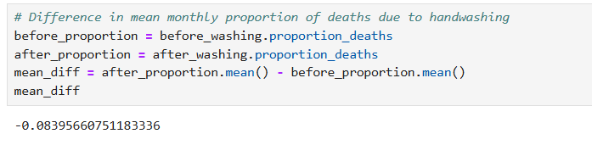
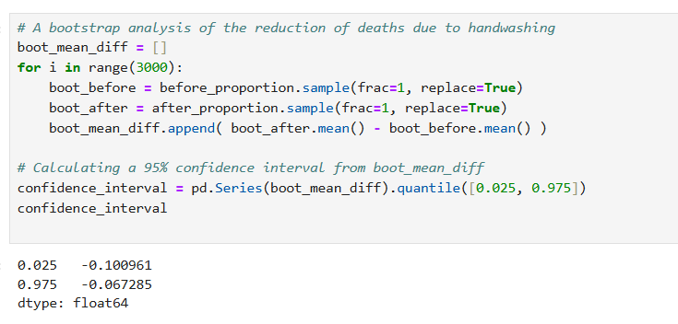

Business Decision Summary
The case of Semmelweis shows that data is not enough to bring change, data communication is what causes either action or opposition. Although it was evident that handwashing significantly lowered the number of mothers dying, the results were at first disregarded due to the fact that they defied the established professional norms and hierarchies. To contemporary organizations, this points to the important strategic lesson, that no amount of persuasive data can work unless that data is packaged in a manner that will be acceptable to the decision-makers.
Leadership wise, the case demonstrates the significance of balancing the data insight with the organizational culture. Semmelweis was skilled at producing numbers, but was unable to convert such results into a story that appealed to physicians in terms of their beliefs and incentives. The same problem occurs in businesses nowadays when implementing data-driven changes that break their usual workflow. Leaders have to combine evidence and empathy, context, and explanations of why the data is important and not only what it demonstrates.
The other strategic lesson learnt is the importance of comparative storytelling. Combined visual trends, before-and-after timelines, and direct comparisons between clinics were the most compelling insights in this scenario. These straightforward contrasts helped to see the problem beneath the surface and they were indisputable. This method can be applied by modern organizations by formulating insights in terms of benchmarks, control groups, or historical baselines and making change simpler to rationalize and communicate.
Another major issue highlighted in the case is the need to relate behavior change with quantifiable results. Washing of hands was not involved as an abstract suggestion; it was depicted as something that affected the survival rates both in the long and short-term. In the business context, that translates to the establishment of a clear connection between the new processes, technologies, or policies and performance gains. Adoption is increased where the cause and effects are visually apparent.
Lastly, the case of Semmelweis shows how expensive the refusal to take data-based insights into consideration can be in the long run. The consequences of not accepting or using evidence in a timely manner caused avoidable loss of life, which demonstrates that opposition to evidence can be quite severe. In the case of contemporary organizations, the risk can either be in the form of lost revenue, inefficiency, reputational damage or missed opportunities. This once again supports the strategic need to nurture a culture that cherishes data storytelling as one of the decision-making instruments instead of considering it as a form of threat to power.

References
Source 1: DataCamp. (n.d.). How data storytelling could save lives: The case study of Ignaz Semmelweis. https://www.datacamp.com/blog/how-data-storytelling-could-save-lives-the-case-study-of-semmelweis

Source 2: Kaggle. (n.d.). Handwashing discovery dataset.
https://www.kaggle.com/datasets/argieg/discovery-of-handwashing-data

OpenAI. (2025). ChatGPT (October 2025 version) [Large language model]. Used for coding assistance and data visualization guidance in Python. https://chat.openai.com
Project Jupyter. (2015). Jupyter Notebook [Computer software]. https://jupyter.org

